Step 1: Glue 5 triangles together
Glue five of the triangles together to make a sort of "lid" like this.

Step 2: Glue 5 more triangles together
Glue another five triangles together to make the bottom of your ornament. Now you have a top and a bottom. If you're a perfectionist, make the bottom a mirror image of the top.

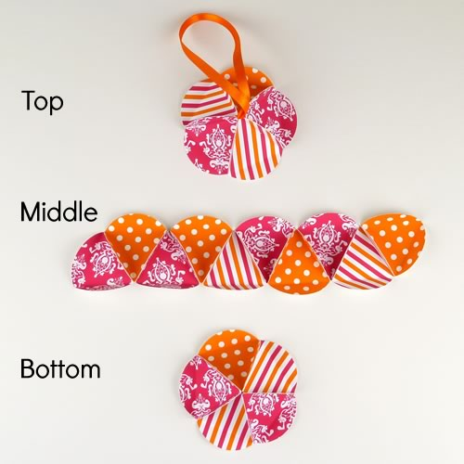
Step 3: Glue 10 triangles together in a strip
Glue 10 triangles together to make a long strip which will become the middle of your ornament.

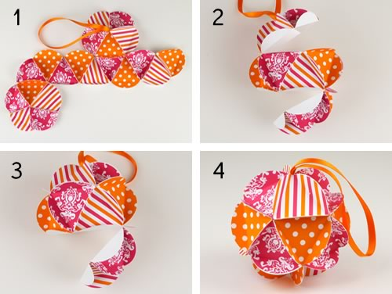
Step 4: Glue the top, middle and bottom together
Final assembly time! To finish your homemade Christmas ornament, all that's left to do is glue the top, middle, and bottom together. I like to do it in this order but you can do it however you like.
1) Glue top and bottom to middle
2) Glue middle to itself to make a circle
3) Glue top onto middle
4) Glue bottom onto middle

