How to use the keyboard to control the mouse
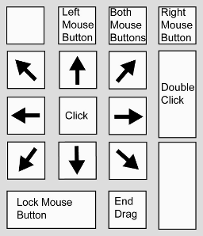
After you have set up your keyboard to control the mouse, you can use the number pad to move the mouse pointer, as well as click, double-click and select and drag, as shown in Fig 1.
Fig 1

Step 1: Move the mouse pointer
You can move the mouse pointer in any direction (vertical, horizontal, diagonal) by using the number keys as shown in Fig 1. Press 4 and 6 to move left and right. Press 2 and 8 to move down and up. Press 1, 3, 7 and 9 to move diagonally.

Step 2: Click the mouse
Before you can click the mouse using the number pad, you need to let it know what type of click you want to make. Press '/' (slash) for a primary click, which is the same as a left-click on a standard mouse. Press '-' (minus) for a secondary click, which is the same as a right-click on a standard mouse.
Once you have selected a click type, press 5 to click the mouse. The click type will stay the same until you change it, so if you have chosen a left-click, every time you press 5 it will make a left-click until you choose another option. (If you have set it up so that the mouse icon appears in your status bar, the icon should show which click type is currently active.)

Step 3: Double-click the mouse
While you can press 5 twice in a row quickly to make a double-click, it is much simpler to press '+' (plus) to double-click the mouse automatically.

Step 4: Select and drag
Move the cursor to the starting point of the area you want to highlight, or place it on the item you want to drag. Make sure the primary button (left-click) is chosen by pressing '/' (slash) and then press 5 to make a left-click.
Press 0 to start selecting or dragging - this is the same as holding down the mouse button. Use the number keys (as described in Step 1) to move the pointer to the end of the area you want to highlight, or to where you want to drag the item. Press '.' (full stop) to release the mouse button.

