Adding a Signature – Orange / Wanadoo
A signature is a small piece of text that's added automatically to the end of each message you send. Signatures typically include contact details, such as office address and telephone numbers, but are also used to add a personal touch to your emails by way of a favourite quote or a link to your website.

1. Click my Settings and click Set up a Signature
2. Click the Signature checkbox
3. Type the text of your signature in the box below the checkbox
4. Click the OK button to confirm your signature. It will now be added to every email you send

Create or modify email signatures on TalkTalk Mail
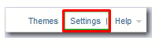
You can set up email signatures. The signature that you create will be automatically added to your emails sent using TalkTalk Mail. Your signature will be added to the bottom of every message you write using TalkTalk Mail.
1. Click the Settings link, located at the top right of your TalkTalk Mail box.

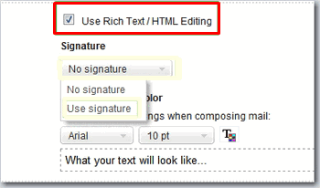
2. Select the Compose section, in the left panel.
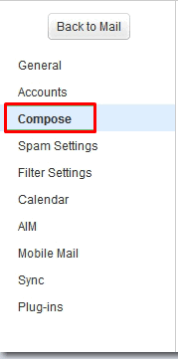
3. The rich text mode is enabled by default in TalkTalk Mail. If you want your signature to appear in plain text, ensure that you clear the Use Rich Text / HTML Editing check box. Otherwise, leave the option checked.

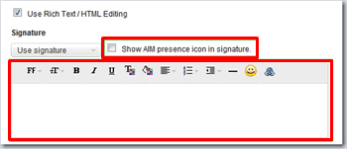
4. Edit your signature's text and formatting in the text box that appears under Signature. Ensure that you select the check box next to Show AIM presence icon in signature if you want your buddy icon to appear in your signature.

5. Click Save.

BT Yahoo Adding a Signature
- Select Mail Options from gear wheel icon top right of window
- Under the Options tab select Signature
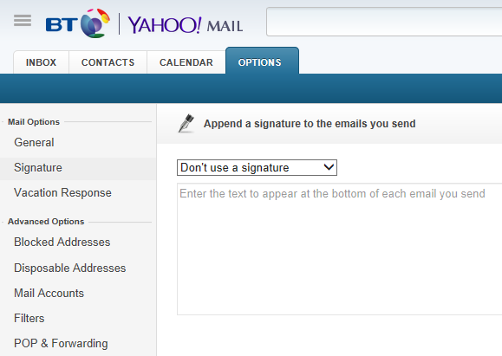
- Use either plain text or rich text as required
- Click the Save button when finished

